Decommissioning host and removing host from cluster and Cloudera Manager

**Login to Cloudera Manager**

* Login to Cloudera Manager using IP address and port 7180

Eg: <http://3.235.181.239:7180/>

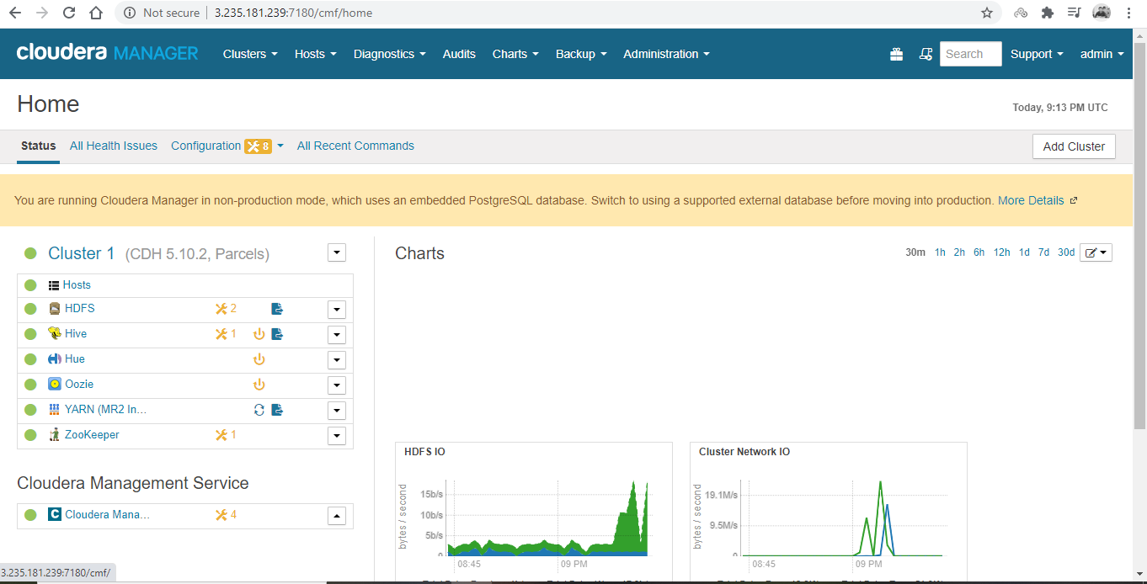

* Now if you want to delete host from the cluster. Go to

Hosts 🡪 All hosts

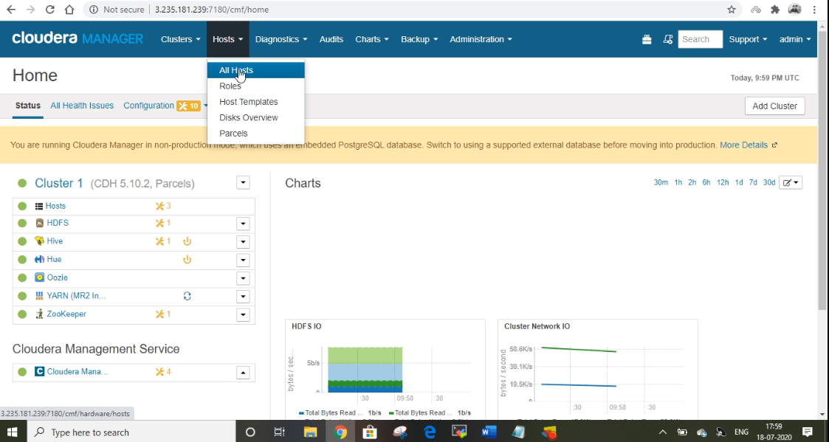

* Select the host you want to delete from the Cluster.

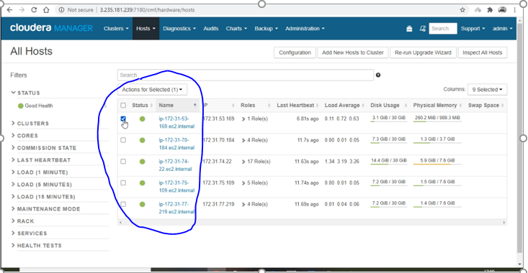

* Click on Actions for Selected 🡪 Select Host Decommission.

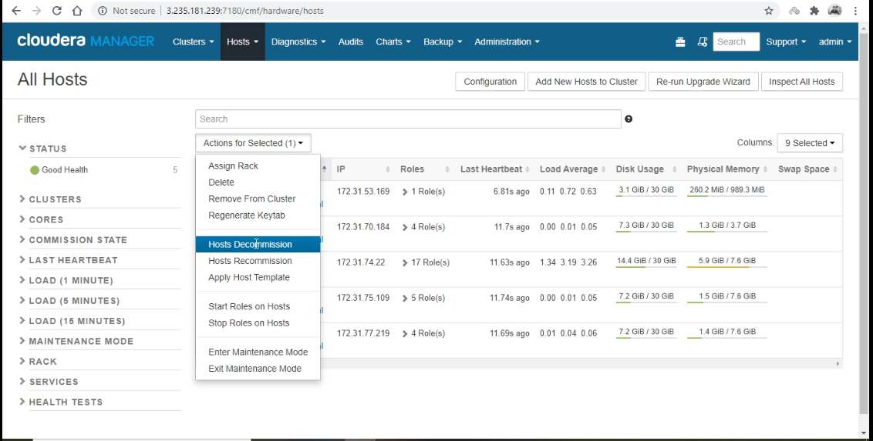

* Click Confirm.

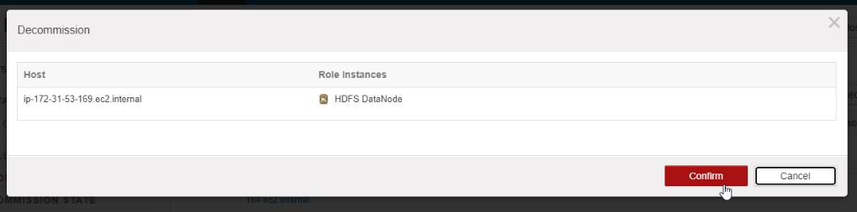

* In the next host decommission takes place where it removes the roles, data on the host and updates the name node metadata. After finishing select close.

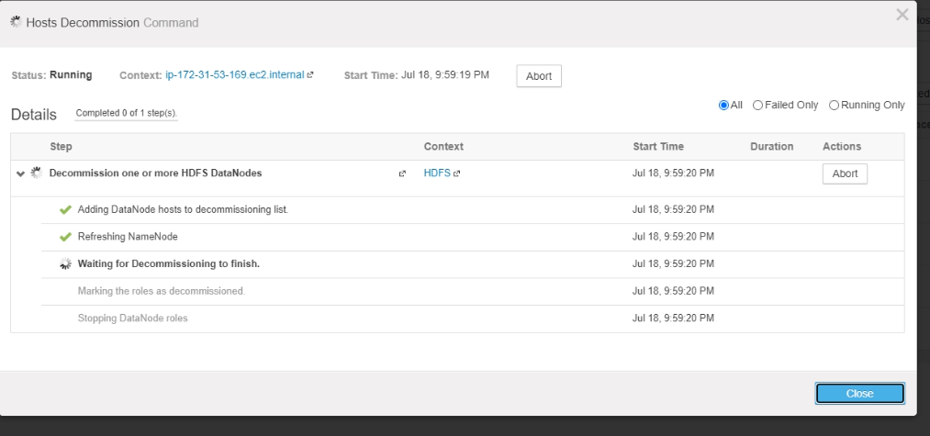

* After decommissioning. Go to Hosts🡪 All Hosts 🡪 Select the host you want to delete 🡪 select Remove from cluster.

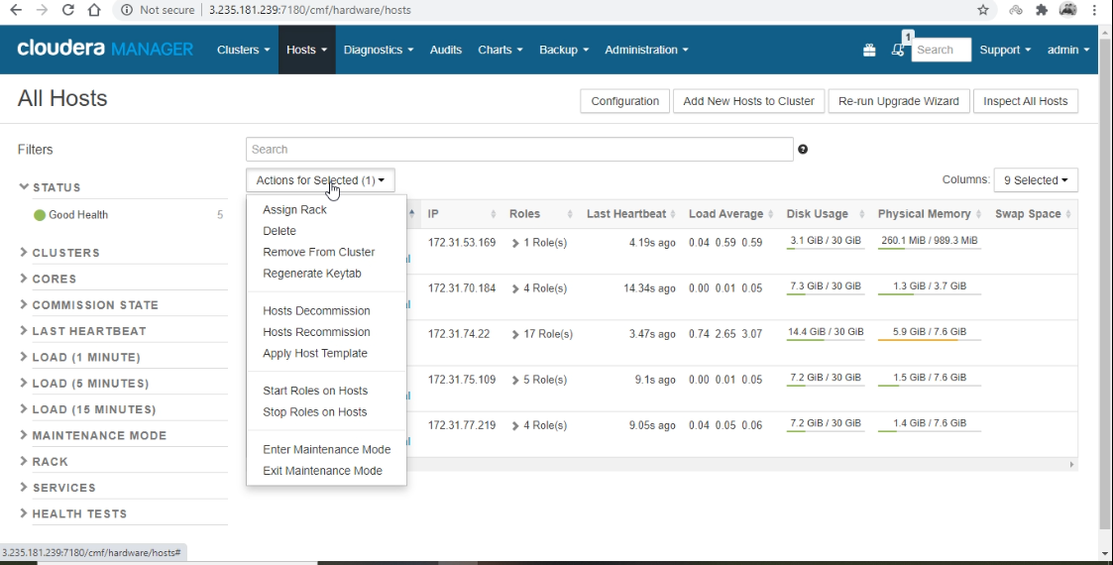

* Click on Confrim.

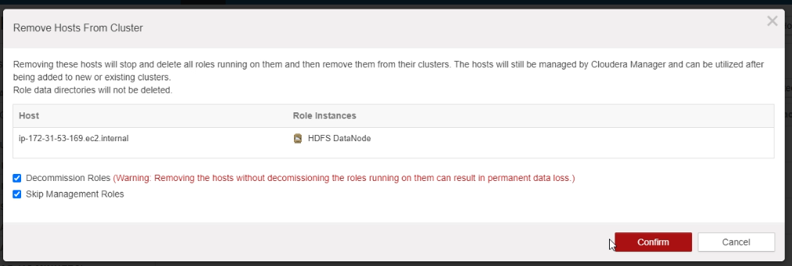

* Removal of hosts from cluster operations takes place. Once done press on close.

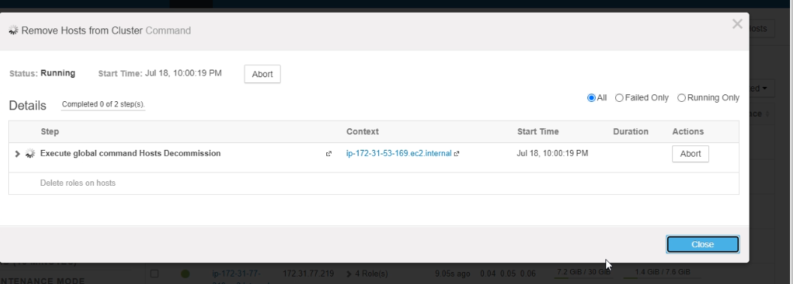

* After removal from cluster. Go to Hosts🡪 All Hosts 🡪 Select the host you want to delete 🡪 select Delete.

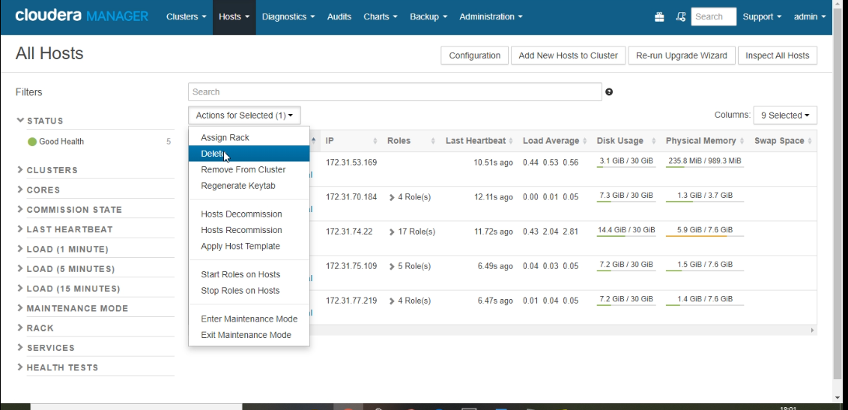

* Select Delete.

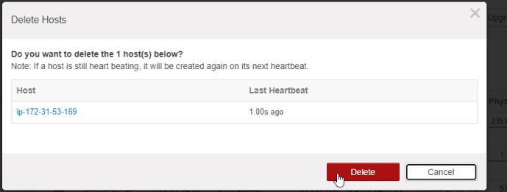

* After deleting you can see the updated hosts list in the cluster.

